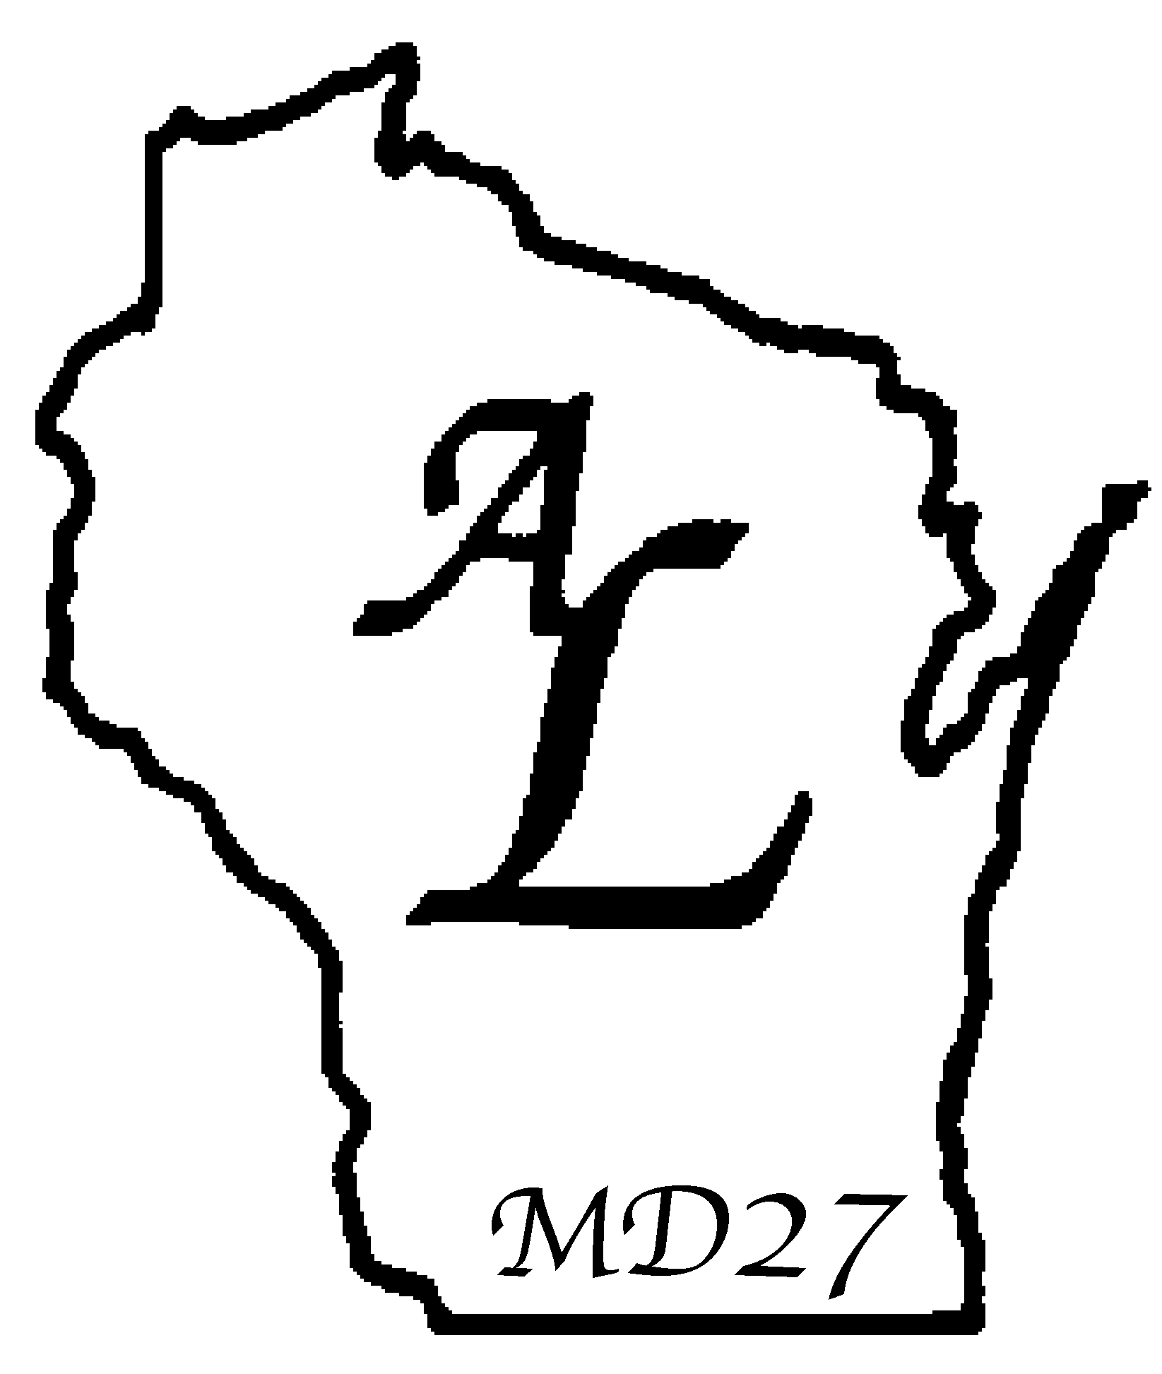
LIONESS CLUB OFFICERS
INSTALLATION CEREMONY

Installing Officer to the audience: It is my privilege and pleasure to be with you today and to install the officers of this Lioness Club for the coming year. The fact that they have been elected by the members of their Club bears witness to the trust placed in them by their sisters in Lionism.

In accord, I too am confident that they can be depended upon to serve their Lioness Club and the humanitarian goals of Lionism to the best of their abilities.

At this time I would like to call each officer to the dais and briefly outline the duties of office, so that both she and all other Lionesses will fully understand the role she is to play in her Club.

(The Lioness Tamer is asked to step forward.)

INSTALLATION OF THE LIONESS TAMER
INSTALLING OFFICER: “Lioness , you have been elected to serve in the role of Lioness Tamer. As such, you will be in charge of the Lioness Club’s property, and will be certain that the flags, gong, gavel and banner are properly displayed. You will see that those in attendance are properly seated. – Will you perform these duties to the best of your ability?”
LIONESS TAMER: “I will.”

(The Lioness Tail Twister is asked to step forward.)

INSTALLATION OF THE LIONESS TAIL TWISTER
INSTALLING OFFICER: “Lioness , you have been elected to serve in the role of Tail Twister. As such, you will be responsible for maintaining harmony and encouraging good fellowship in the best tradition of the Tail Twister. You will act as an official greeter and will welcome and introduce guests. You may impose and collect fines in order to promote fun and friendship within your Club. – Will you perform these duties to the best of your ability?”
LIONESS TAIL TWISTER: “I will.”

(The Lioness Club Directors are asked to step forward.)

INSTALLATION OF THE LIONESS CLUB DIRECTORS
INSTALLING OFFICER: “Lioness , Lioness , and Lioness , you have been elected to the important position of Director, and as such, you will assist in forming and implementing the policies that will determine the future of your Club. You will faithfully attend the regular and special meetings of your Club and will put forth your best efforts to direct the progress of your Lioness Club. – Will you perform these duties to the best of your abilities?”
LIONESS CLUB DIRECTORS: “I will.”

(The Vice-Presidents are asked to step forward.)

INSTALLATION OF VICE-PRESIDENTS
INSTALLING OFFICER: “Third Vice-President Lioness , Second Vice President Lioness , and First Vice-President Lioness , you will cooperate with the other officers and directors of your Club in forming the policies that will guide your Club and its members. Additionally, each of you will oversee the functioning of committees whose performance is vital to the Lioness Club. You will motivate the Lioness membership to become active in all Club affairs. Furthermore, you, in order of your office and presence, will substitute for the President in her absence from any Club or Board of Directors meeting. – Will you, as Vice-Presidents, perform these duties to the best of your abilities?”
LIONESS VICE PRESIDENTS: “I will.”

(The Secretary is asked to step forward.)

INSTALLATION OF SECRETARY
INSTALLING OFFICER: “Lioness , you have been elected to serve your Club as Secretary – one of the most important offices in your Club. You are the President’s closest assistant. You will receive many important communications, and it is your duty to see that your Board of Directors and your Club receive those which require their attention. You shall keep the general Club records, including minutes of the Club and Board Meetings, Committee appointments, officers’ list, attendance records, and a roster of the members. You shall issue membership cards and you shall collect from all members and others, all monies due the Club. In addition, you shall submit regular monthly Project and Activity Reports. You shall furnish financial statements as requested to the Board of Directors, to the Lioness Club membership and to your sponsoring Lions Club. You shall report to the Board the name of all members who are in arrears in payment of dues and those who have absented themselves beyond the attendance requirement provided in the Constitution and By-Laws. – Will you, as Secretary, perform these duties to the best of your ability?”
LIONESS SECRETARY: “I will.”

(The Treasurer is asked to step forward.)

INSTALLATION OF TREASURER
INSTALLING OFFICER: “Lioness , you have been elected to serve your Club as Treasurer. You will be custodian of all Club funds, depositing them in such bank or banks as are designated by your Board of Directors. You will assist the Finance Committee in preparing a budget and such financial statements as may be necessary. You will disburse funds only upon direction of the Board of Directors. – Will you, as Treasurer, perform these duties to the best of your ability?”
LIONESS TREASURER: “I will.”

(The President is asked to step forward.)

INSTALLATION OF PRESIDENT
INSTALLING OFFICER: “Lioness , you have been elected to the office of President of your Club. You are its Chief Executive Officer, and will preside at all meetings of your Club and regular and special meetings of your Board of Directors. You will, in accordance with the Lioness Club Standard Constitution, appoint committees necessary to the functioning of your Club, and act as an ex-officio member of each of these committees. With the assistance of your Vice-Presidents, you shall see that these committees function. You will maintain contact with the Lioness Club (Lion) Liaison, to coordinate the activities of your Club with those of the Sponsoring Lions Club.

In addition, you shall serve as an example of spirit and dedication for the Lioness Club members, and you shall show each member that you care about her participation in the Club and the unique talents she has to offer in the service of others through your Lioness Club. – Will you, as President, perform these duties to the best of your ability?”
LIONESS PRESIDENT: “I will.”

(The Immediate Past President is asked to step forward.)

INSTALLATION OF IMMEDIATE PAST PRESIDENT
INSTALLING OFFICER: “Lioness , you have served your Club well during your Presidency, and the membership still has need of your knowledge and leadership. You will serve as a member of the Board of Directors, and you will lend assistance to the incoming President, providing her with needed records and reports, and sharing with her what you have learned in your Presidency. You will continue to exercise the same concern for the involvement of all Lionesses in Club activities as you did during your term in office. – Will you perform these duties to the best of your ability?”
IMMEDIATE PAST PRESIDENT: “I will.”

IMMEDIATE PAST PRESIDENT (RESPONSE) (OPTIONAL)
“Lionesses, I wish to thank you sincerely for the help and support you have given me throughout my term as President. I ask that you honor my successor with as much affection and assistance. (Approaches Incoming President) Lioness President , please accept this gavel with my best wishes for a successful year. I will do my best to assist you in every way.”

ADDRESS TO LIONESS OFFICERS AND DIRECTORS
INSTALLING OFFICER: “Lioness Officers and Directors, the policies and the achievements of this Lioness Club will depend largely upon your actions. I ask you now, will you individually and collectively promise to stand by your Club, live with it and work with it, and give as much of your time and effort as is necessary to properly perform your official duties?”
LIONESS OFFICERS AND DIRECTORS: “I will.”

ADDRESS TO LIONESS MEMBERSHIP
INSTALLING OFFICER: “Will all the Lioness Club members please rise? You have entrusted these Lionesses with the responsibilities of your Club for the coming year, and they have pledged themselves to perform their duties to the best of their abilities. For them to succeed and, in turn, for your Lioness Club to succeed, these Officers and Directors and your Club must have the fullest support of each and every one of you.

Lionesses, I now ask you, will you faithfully assist the leaders of your Club, and will you give of yourselves, actively and unselfishly, so that your Club will prosper and so that the noble goals for which it strives will be met?”
LIONESS CLUB MEMBERS: “I will.”

INSTALLING OFFICER: “It is my pleasure to declare these Lionesses duly installed into the respective offices to which they have been elected.

Lionesses, may you all enjoy a year in which friendship and fellowship will flourish. And may your every effort to assist the needy be fruitful.”

THE INSTALLING OFFICER WILL THEN GIVE THE ADDRESS OR MAY BE THE GUEST SPEAKER AND CONCLUDE THE CEREMONY.

