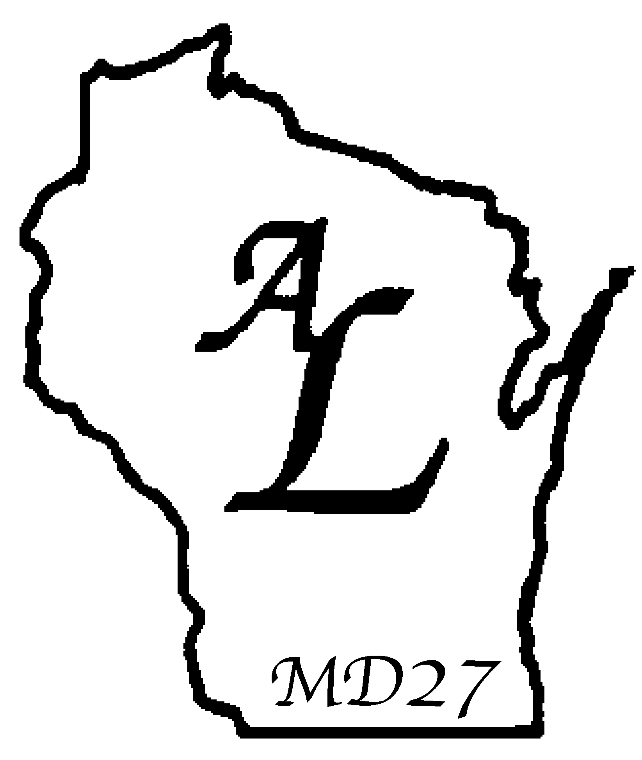
DISTRICT OFFICER
INSTALLATION CEREMONY

Installing Officer: It is my privilege and pleasure to be with you today and to install the officers of Affiliate District for the coming year. The fact that they have been elected by the Lionesses of their District bears witness to the trust placed in them by their sisters in Lionism. I am also confident that they can be depended upon to serve their Affiliate District and the humanitarian goals of Lionism to the best of their abilities.

At this time I would like to individually ask each officer to come forward, one at a time. I will briefly outline the duties of each office, so that both the officer and the other Lionesses will fully understand the role she is to play in her District.

NOTE: In those Districts where the Affiliate District Secretary and Affiliate District Treasurer are appointed rather than elected, change ‘elected’ to ‘selected’ in the installation of those officers.

(The Treasurer is asked to step forward.)

INSTALLATION OF TREASURER

INSTALLING OFFICER: “Lioness , you have been (s)elected to serve your District as Treasurer. You will be custodian of the District funds, depositing them in whichever financial institution is designated by the Affiliate District Cabinet. The District Treasurer shall set up accurate records and accounts for the Affiliate District which shall be open to the inspection of the Cabinet and auditor. You will disburse funds only upon direction of the Board of Directors.”
Will you, as Treasurer, perform these duties to the best of your ability?”
DISTRICT TREASURER: “I will.”

(The Secretary is asked to step forward.)

INSTALLATION OF SECRETARY

INSTALLING OFFICER: “Lioness , you have been (s)elected to serve your District as Secretary. The District Secretary keeps an accurate and complete record of the business conducted at cabinet meetings and District Convention. Each club will send its District dues to the Secretary who will be responsible for the record keeping and collection of these funds. The Secretary will keep an updated listing of the names and addresses of Elected District Officers and submit in proper form to the District Governor.
Will you, as Secretary, perform these duties to the best of your ability?”
DISTRICT SECRETARY: “I will.”

(The Vice-President is asked to step forward.)

INSTALLATION OF VICE-PRESIDENT

INSTALLING OFFICER: “Lioness , you have been elected to serve your District as Vice President. The Vice President shall assist the President as much as possible, sharing in the responsibility and leadership; making recommendations and helping to plan programs; and advising the President on pending or arising situations through contact with Club and District officials, representatives or committees. The Vice President shall act as presiding officer in the absence of the District President.
Will you, as Vice-President, perform these duties to the best of your ability?”
DISTRICT VICE PRESIDENT: “I will.”

(The President is asked to step forward.)

INSTALLATION OF PRESIDENT

INSTALLING OFFICER: “Lioness , you have been elected to the office of President of your District for the coming year. You are this Affiliate District’s Chief Executive Officer, and as such, are expected to uphold the rules set forth in the Affiliate District Constitution. You will preside at all meetings of your Cabinet. In addition to elected Cabinet members, other Cabinet members may be appointed by you that have been proposed by the Affiliate District Constitution. The Lioness Clubs of this District will look to you for leadership through your establishment of goals. You will be expected to communicate with the District’s Lioness Clubs and to be available to offer assistance and support when needed.
Will you, as President, perform these duties to the best of your ability?”
DISTRICT PRESIDENT: “I will.”

NOTE: If the Affiliate District By-Laws state that the Immediate Past District President is a member of the Affiliate District Cabinet, the Immediate Past District President is asked to step forward.

(The Immediate Past President is asked to step forward.)

INSTALLATION OF IMMEDIATE PAST PRESIDENT

INSTALLING OFFICER: “Lioness , you have served your District well during your Presidency. The membership still has need of your knowledge and leadership. You are invited to serve as a member of the Affiliate District Cabinet, lending assistance to the incoming President and sharing with her your appraisal of the District.
Will you, as Immediate Past President, accept your rightful position on this Affiliate District Cabinet?”
IMMEDIATE PAST PRESIDENT: “I will.”

IMMEDIATE PAST PRESIDENT RESPONSE

“Lionesses, I wish to thank you sincerely for the help and support you have given me throughout my term as President. I ask that you extend these same courtesies and assistance to Affiliate District President during her term in office. I, in turn, pledge my support to Affiliate District President and will do my best to assist her in every way.”

ADDRESS TO LIONESS OFFICERS

INSTALLING OFFICER: “Affiliate District Lioness Officers, the policies and the achievements of this Affiliate District will depend largely upon your actions. I ask you now, will you individually and collectively promise to give as much of your time and effort as is necessary to properly perform your official duties?”
LIONESS OFFICERS: “I will.”

ADDRESS TO CABINET MEMBERS

INSTALLING OFFICER: “Will all the Lioness Cabinet members please rise? You have entrusted these Lionesses with the responsibilities of your District for the coming year, and they have pledged themselves to perform their duties to the best of their abilities. For them to succeed and, in turn, for the Lioness to succeed, these Officers and your District must have the fullest support of each and every one of you.

Lionesses, I now ask you, will you faithfully assist the leaders of your Affiliate District, and will you give of yourselves, actively and unselfishly, so that the Lioness program will prosper and so that the noble goals for which it strives will be met?”
CABINET MEMBERS: “I will.”

INSTALLING OFFICER: “It is my pleasure to declare these Lionesses duly installed into the respective offices to which they have been elected. Lionesses, may you all enjoy a year in which friendship and fellowship will flourish. And may your every effort to assist the needy be fruitful.”

