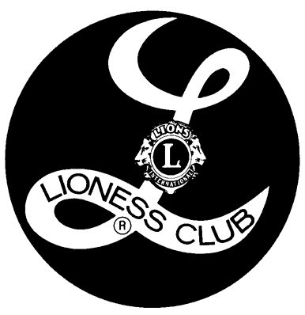
= = = = = = = = = = = = = = = = = = = = = = = = = = = = = = = = = = = = = = = = = = = = = = = = = =
[Complete, clip here and mail in to receive yor invitation to a Lioness meeting]

YES, I WANT TO MAKE A DIFFERENCE! I WANT TO IMPACT OUR WORLD.

Name: ________________________________e-mail: ____________________________

Address: _____________________________________________________________________

Phone: ________________________________ Best time to reach me:______________ am / pm
OUR LIONESS SERVICE

COMMUNITY SERVICE PROJECTS
INSERT SERVICE PROJECT
INSERT SERVICE PROJECT
INSERT SERVICEPROJECT
INSERT SERVICE PROJECT

COMMUNITY DONATIONS
INSERT COMMUNITY DONATION
INSERT COMMUNITY DONATION
INSERT COMMUNITY DONATION

LIONESS CHARITIES
INSERT LIONESS CHARITY
INSERT LIONESS CHARITY
INSERT LIONESS CHARTY
INSERT LIONESS CHARITY
INSERT LIONESS CHARITY
INSERT LIONESS CHARITY
INSERT LIONESS CHARITY

IMPACT OUR WORLD

To receive your invitation and join the Lioness in making a difference in our community, contact:

INSERT NAME LIONESS CLUB
INSERT ADDRESS
INSERT CITY, WI ZIP
INSERT PHONE NUMBER

WEBSITE URL OR
E-MAIL ADDRESS

Why Be A Lioness? For friendship, fellowship, enjoyment, creative uses of time and service to others.

Who Can Be A Lioness? Any person 18 years or older and who is service minded. Membership is by invitation, so contact us today and receive your invitation!

What Is The Purpose of A Lioness Club? To provide challenging, varied community service opportunities for members. We also assist our sponsoring Lions Club in carrying out its service programs and activities in the community.

What Is The Lioness Motto?
"WE SERVE TOO"

