
Lioness members are volunteers who, with care and compassion, reach out and address areas of need in our communities.

There are more than 2,800 Wisconsin Lioness members in 106 communities statewide. Information on the Wisconsin Lioness program can be found at www.wisconsinlioness.org

Lioness members are affiliate members of Lions Clubs - an international network of 1.3 million men and women in 205 countries and geographic areas. Lioness Clubs can be found in many countries outside of the United States as well.

WHAT IS THE LIONESS PROGRAM?

Officially acknowledged 55 years after Melvin Jones founded Lions Clubs International, the Ladies Auxiliary of Mt. Pleasant, North Carolina, became the first Lioness Club on December 24, 1975. This group of 40 women, like other auxiliaries around the world, received a special award for their retroactive service to Lionism.

The Lioness Club Program enjoys a separate club constitution with suggested by-laws. In 1975, the name "Lioness Clubs" and the scripted, "L" logo were officially approved for use by Lions Clubs International. In June 1980, the first Lioness District was organized in Turkey. In January of 1981, the first multiple District was recognized in Oregon, USA.

From its beginnings through today, Lioness members continue to address areas of need within our community, our State and worldwide. Join us and together we can make our world a better place!

Are you…

- Interested in meeting new people?
- Looking for New Experiences?
- Helping others?
- Making an impact at home and around the world?

Then you want to be a Lioness member!

WE SERVE TOO!
MEMBERSHIP MEETINGS

The Club meets monthly, on the
XXX day of each month.

BOARD MEETINGS

The Board of Directors meet
Monthly, on the XXX day of
each month.

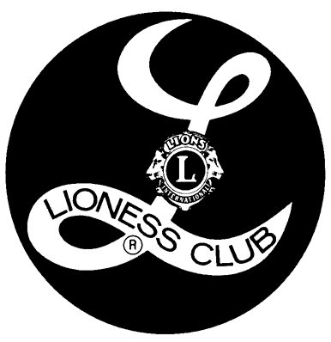
INSERT NAME LIONESS CLUB
INSERT ADDRESS
INSERT CITY, WI ZIP
INSERT PHONE NUMBER

WEBSITE URL OR
E-MAIL ADDRESS

WE SERVE TOO!

