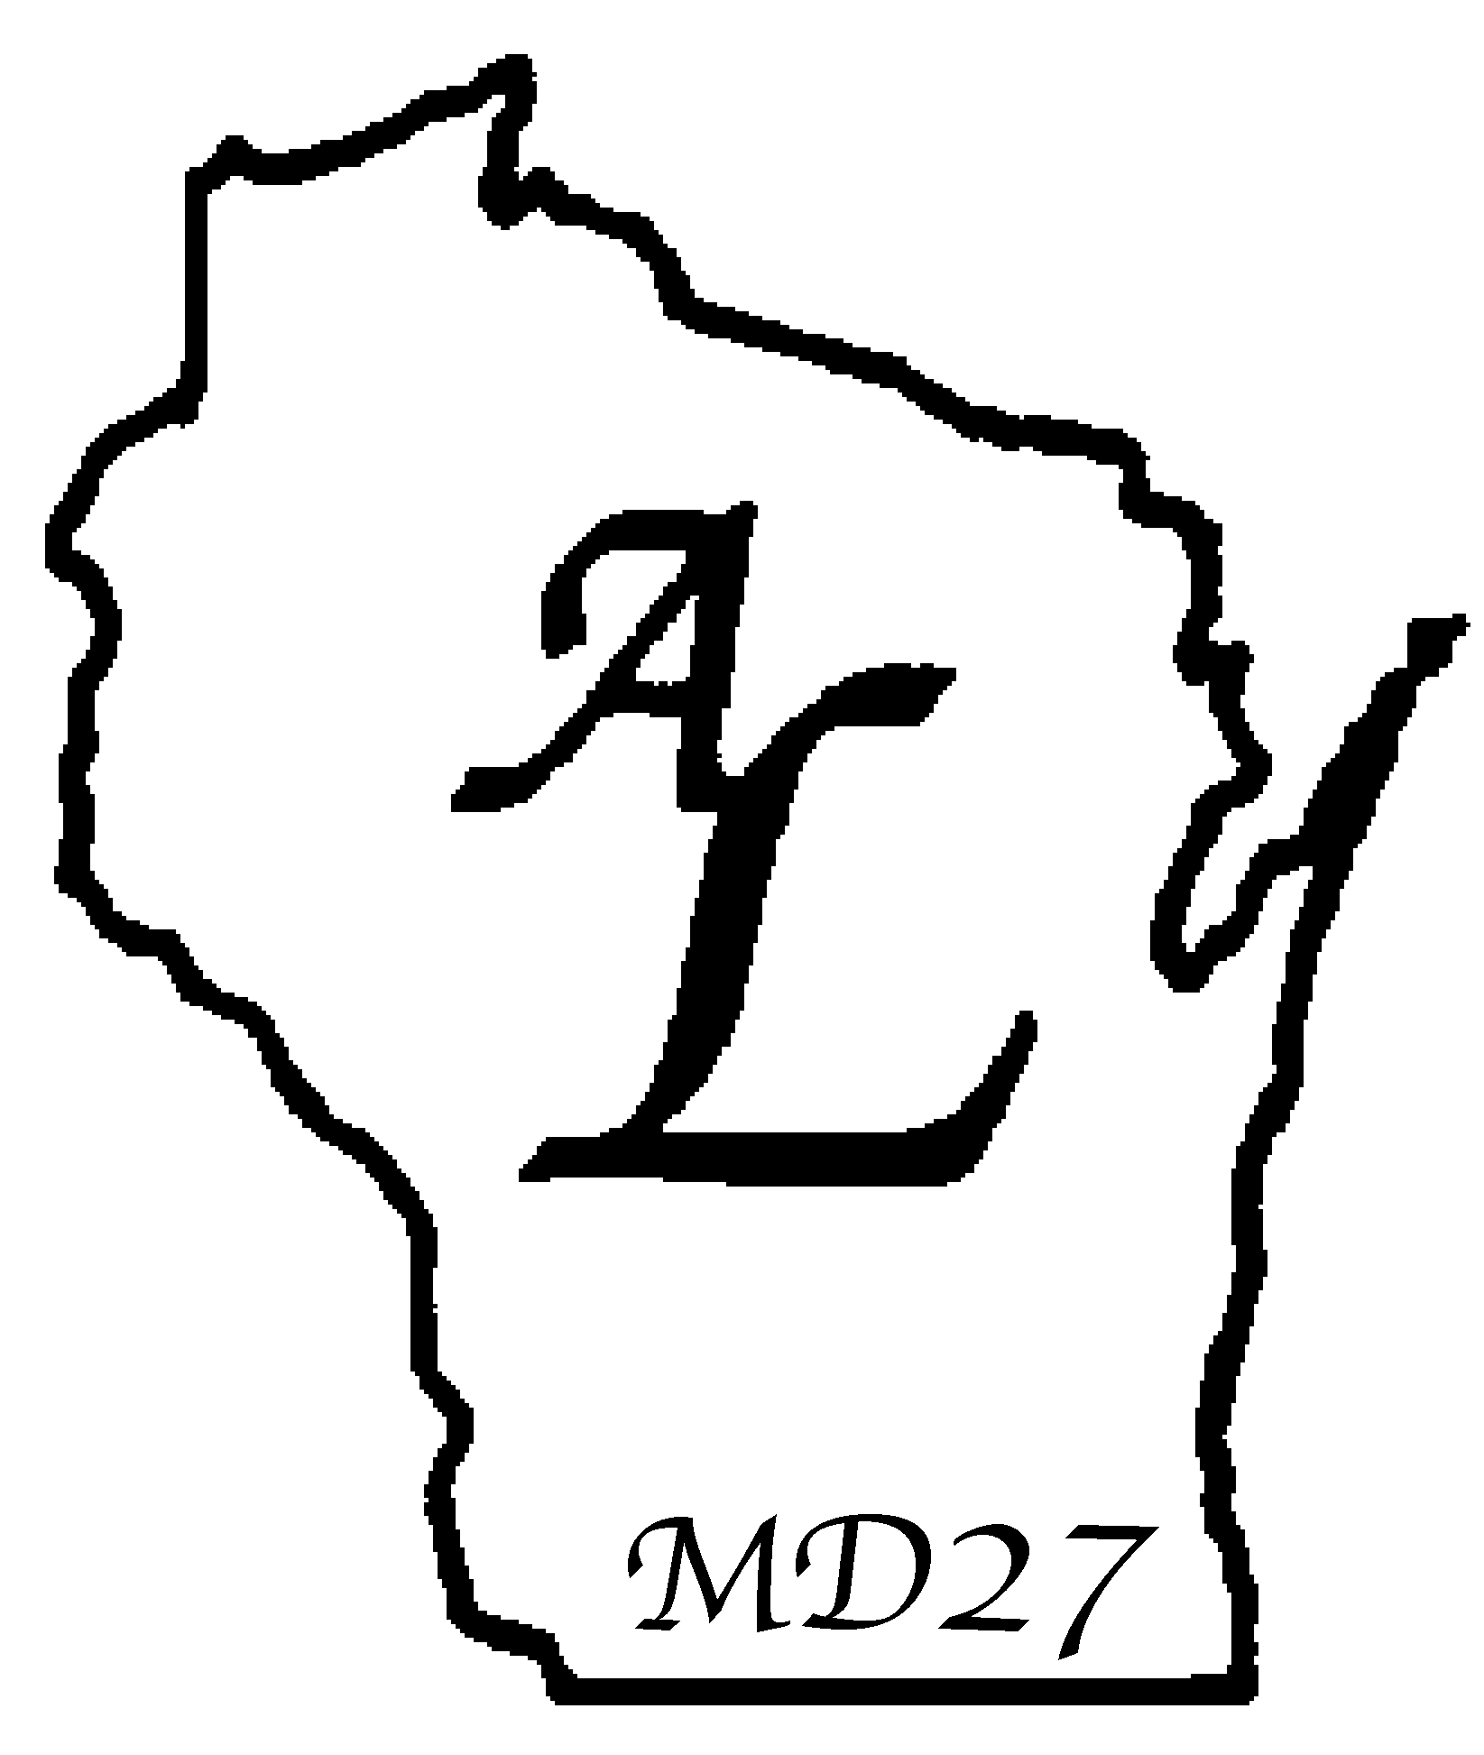
LIONESS CLUB

NEW MEMBER INITIATION

(This initiation service is done with candles. Items needed for this initiation: 1-2 ½” diameter candle and a taper candle for each new member and a flower to be given at the end for each new member.)

Officiant to the audience: We are now about to begin the initiation ceremony which will officially welcome the(se) new member(s) to the Lioness Club. The candle burning on the table signifies the sponsoring Lioness and all other members of the Lioness club. When the member(s) light their candles from it at the end of the ceremony, they will be signifying their affirmation of membership in the Lioness club.

Officiant: As I call the name(s) of each new member(s), will the new member(s) and their sponsoring Lioness come forward? (Officiant presents the sponsor with the flower and presents the new member with the candle. Invite the sponsor to introduce the new member.)

Officiant to new member(s): Lioness you have accepted a challenge to serve others, and are now a part of a world wide group of citizens who are affiliated with the world’s largest service organization, multiple district 27 of Wisconsin. Clubs throughout the world find the needs of others and they satisfy them. Together, we can do things an individual cannot do alone. This is the challenge offered to you, Lioness by Multiple District 27 and the Lioness Club. I am sure that you will find the more you become involved, the more fellowship and friendship will come your way. Enjoy your experiences with Lioness and you will enrich your life through serving others.

Officiant to new member(s): Lioness do you wish to affirm your membership in Lioness? If so, please respond “I do.”

New Member(s): I do.

Officiant to new member(s): Please repeat after me:

I DO HEREBY AFFIRM MY MEMBERSHIP
IN THE __ __ LIONESS CLUB.
KNOWING THAT SUCH MEMBERSHIP
OBLIGATES ME TO PARTICIPATE
IN ALL FUNCTIONS OF THE CLUB.
TO THE BEST OF MY ABILITY
I WILL ATTEND MEETINGS REGULARLY,
VOLUNTEER AND CONTRIBUTE
MY SHARE OF TIME, TALENT AND EFFORT
TO THE PROGRAM OF MY CLUB
MY SPONSORING LIONS CLUB AND
MULITPLE DISTRICT 27 OF WISCONSIN

(Sponsor presents/affixes Lioness membership pin)

Officiant to new member(s): Please light your candle now, as a symbol of your membership affirmation and commitment to Lioness.

(Sponsor presents new member with the flower.)

Officiant to audience: Please join me in welcoming our new member(s) with a round of applause.

