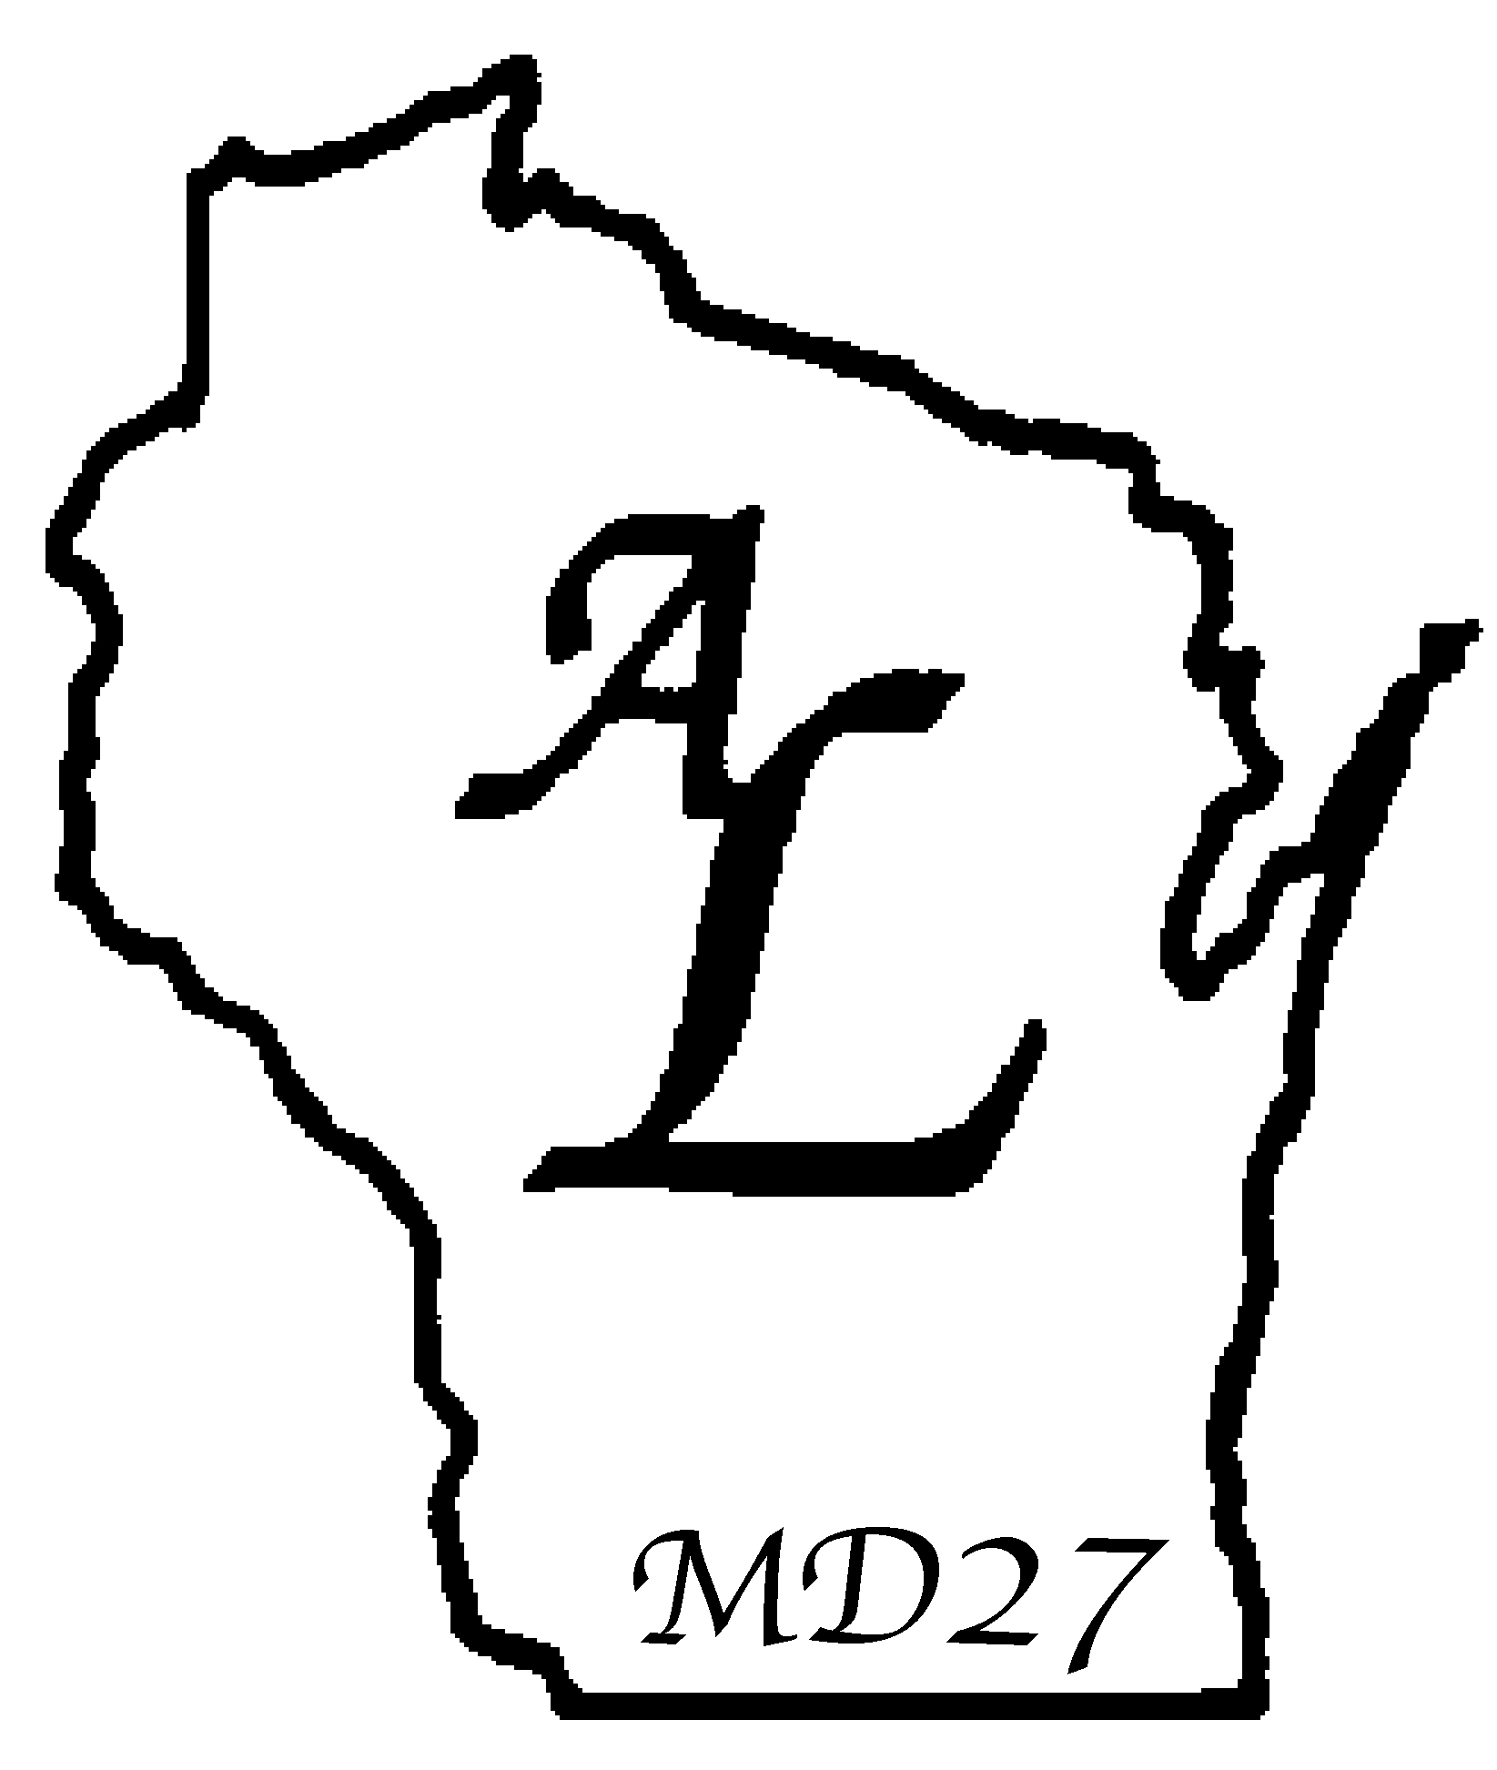

LIONESS CLUB OFFICERS FORM
FOR FISCAL YEAR
JULY 1, 2 THROUGH JUNE 30, 2 .
The outgoing Lioness Club President must use this form to report the names and address of the newly-elected Club Officers for the upcoming Lionistic year.

THIS INFORMATION IS EXTREMELY IMPORTANT! All communications your new officers receive during their year in office and address in the State Lions Directory will be based on the information you provide here. Lioness Newsletters and other pertinent mailings will be addressed to the Officers at the addresses shown below. Please type or print clearly the needed information on this form and mail it on or before to: your District President and District Governor (and/or District Secretary, as appropriate to your District).

DISTRICT 27-
NAME OF CLUB:

Please indicate day, week and hour of general (g) meeting and board (b) meeting:

 | MON | TUES | WED | THURS | FRI | SAT
1st Week
2nd Week
3rd Week
4th Week

Meeting Place:
Meeting Place Address:
Number of Members:

President:
Street:
City, ZIP:
Phone (area & phone #): Home Cell Work
Phone (area & phone #): Home Cell Work
E-mail:

COMPLETE PAGE 2 ALSO
Secretary:
Street:
City, ZIP:
Phone (area & phone #): Home Cell Work
Phone (area & phone #): Home Cell Work
E-mail:

Treasurer:
Street:
City, ZIP:
Phone (area & phone #): Home Cell Work
Phone (area & phone #): Home Cell Work
E-mail:

Membership:
Street:
City, ZIP:
Phone (area & phone #): Home Cell Work
Phone (area & phone #): Home Cell Work
E-mail:

Lions Club Liaison:
Street:
City, ZIP:
Phone (area & phone #): Home Cell Work
Phone (area & phone #): Home Cell Work
E-mail:

PROVIDE LIST OF NAMES (WITH ADDRESSES and E-MAIL, IF POSSIBLE) OF ALL CLUB MEMBERS ON ANOTHER SHEET AND ATTACH

PLEASE MAIL BY TO THE FOLLOWING LISTED PEOPLE:
- Affiliate District President
- District Governor
- Affiliate District Secretary

