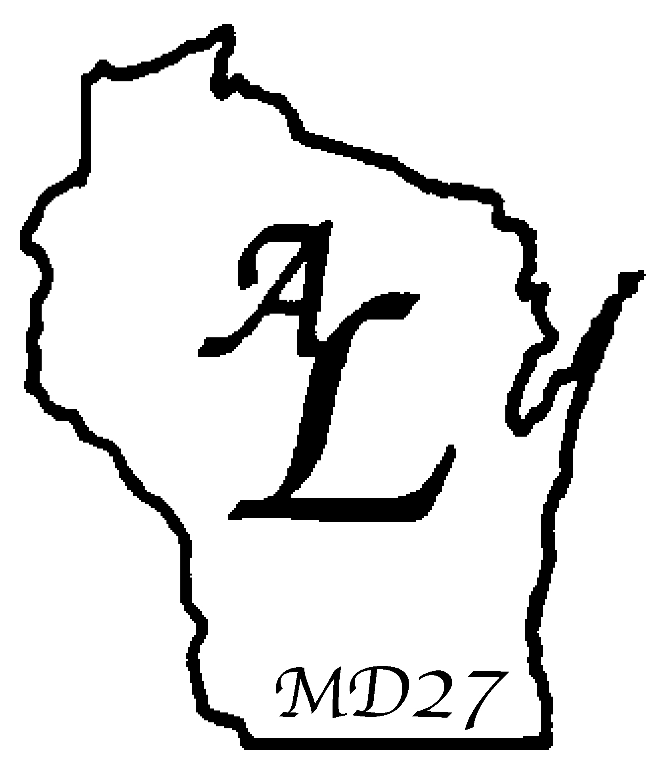

Affiliate Clubs
Quarterly District Membership Report
2018-2019

DUE DATES: July 13, 2018 for April – June 2018 (mtg 7/28/18)
September 28, 2018 for July-August 2018 (mtg 10/6/18)
January 4, 2019 for September-November 2018 (mtg 1/12/19)
February 22, 2019 for December 2018-January 2019 (mtg 3/2/19)
May 3, 2019 for February –March 2019 (mtg 5/17/19)

Date:

District: 27-

Be sure your starting number is the same as the ending number from the preceding quarter.

TOTAL MEMBERS END OF LAST QUARTER
TOTAL MEMBERS ADDED THIS QUARTER
TOTAL MEMBERS DROPPED THIS QUARTER
TOTAL MEMBERS END OF THIS QUARTER

CLUBS CHARTERED DURING THIS QUARTER

CLUBS DISBANDED DURING THIS QUARTER
(Attach LC-11 Disbanded Lioness Club Check Off List)

Name of Disbanded Club:

Submitted by:
District President/Associate

Mail Completed Form To: Lioness/Lion Patt Goerke
S15 W22072 Woods View Ct.
Waukesha, WI 53186
pattgoerke@yahoo.com

